**EXPERIMENT 6**

DML COMMANDS (COLLEGE SCHEMA)

Aim:

* Insert 5 instances into the tables created in experiment 5.
* Display the tables.
* Add attribute course to student table then insert values.
* Use update to set course for students.

1. Insert 5 instances into the tables created in experiment 5.

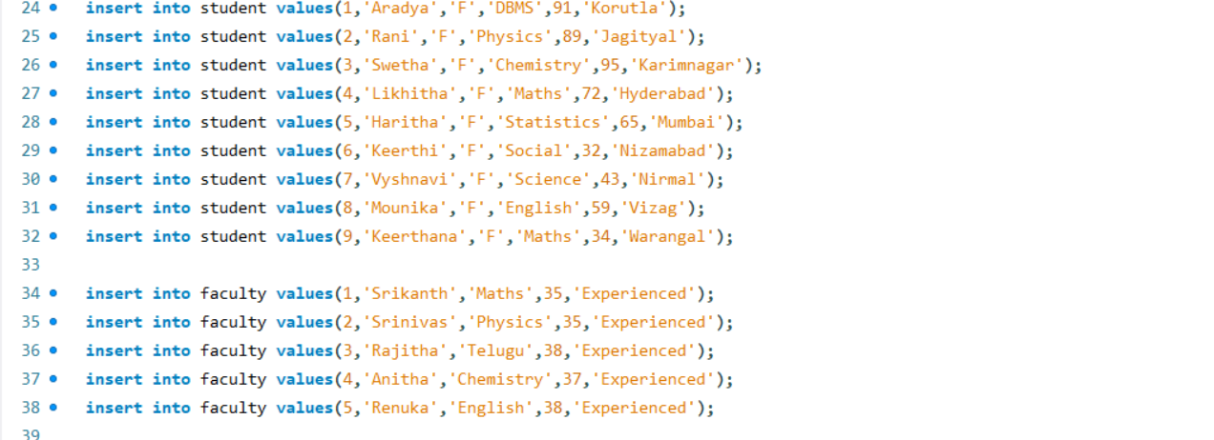

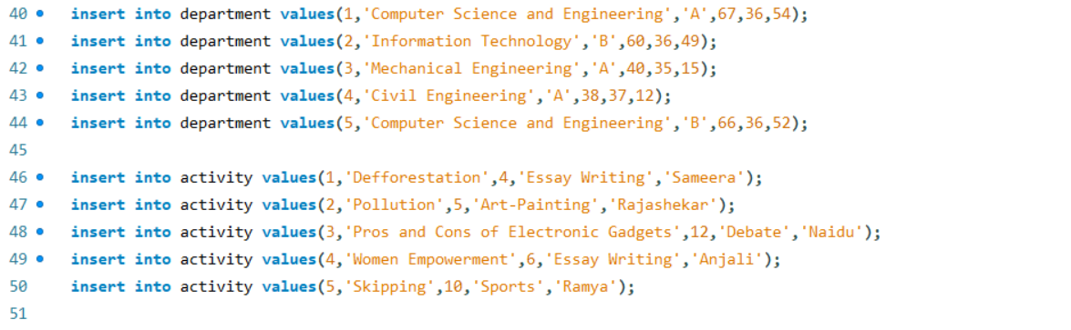

1. Display the tables.

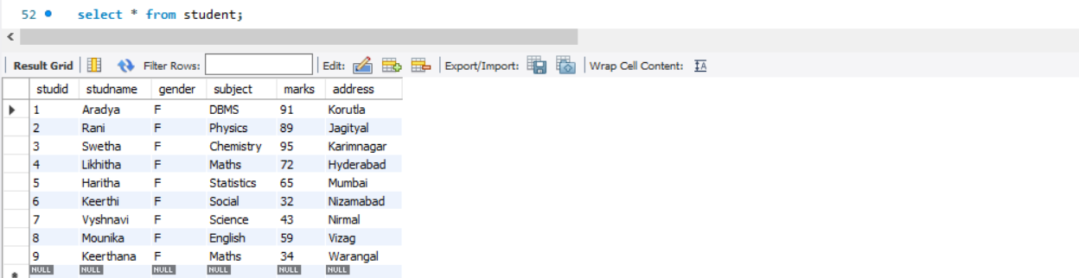

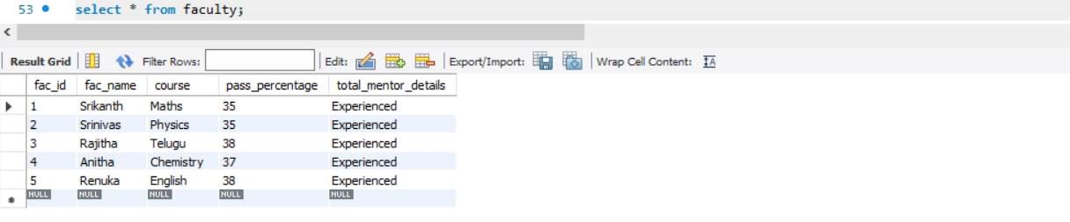

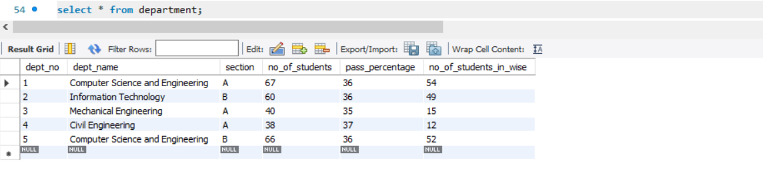

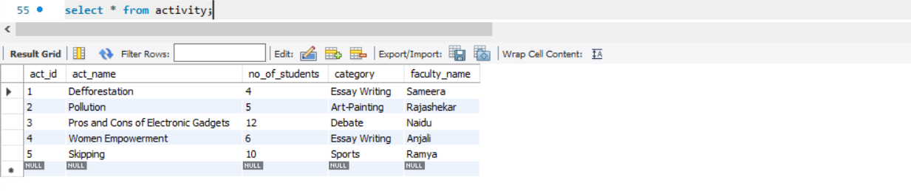

1. Add attribute course to student table then insert values.

Use update to set course for students.

